# Neural Networks

## What is a Neural Network?

“A neural network is a series of algorithms that endeavours to recognize underlying relationships in a set of data through a process that mimics the way the human brain operates. In this sense, neural networks refer to systems of neurons, either organic or artificial in nature. Neural networks can adapt to changing input; so the network generates the best possible result without needing to redesign the output criteria” – James Chen

As per the definition above, in the lesson 2: Chapter 13, the lesson states that usually neutral networks makes decisions based on weighing evidence. Usually the inputs are Yes/No questions while the outputs are also Yes/No questions.

### Example

In lesson, the tutor gives a question where it is based on an relatable question. In this case, neural can come in to assist with the decision making.

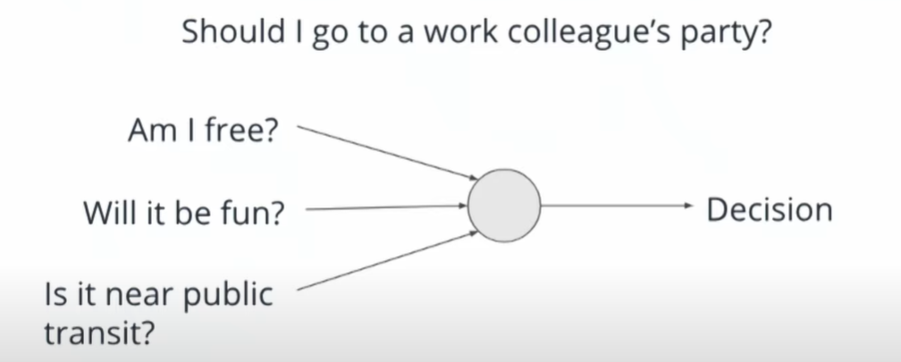

Usually making this decision can be much more complicated than just the one shown above so threshold and weights are introduced to this image,

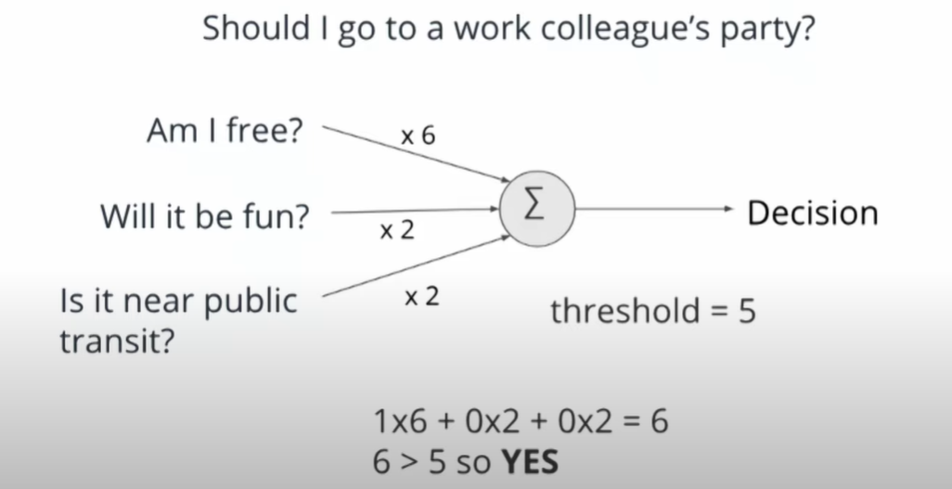

But because of the fact that the threshold is leaning more toward whether you are free, the tutor increased the threshold/changed the weights around in order to have the other choices matter too.

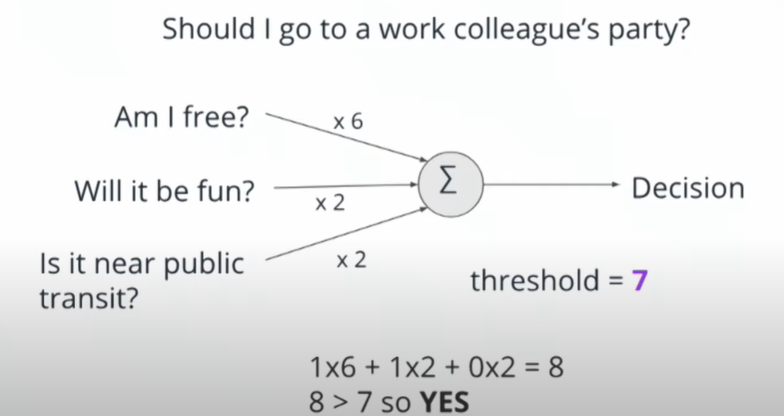

It is to note that it is vital that you and your team know all the important decisions making factors and criteria as it is imperative for what makes a good model. Models are usually not good or bad, just reflective of the inputs and decision making criteria that you give them.

Usually, the decision above is one neuron from a collection of neurons. In this case, it uses that decision as input for another decision. This could also be called as a deep neural network, where each layer makes decisions based on the decisions made in the prior layer. It is an artificial neural network with multiple layers between the input and the output layers. It can be dozens or hundreds, even thousands of layers between the input and the output.

### Application of neural networks today

Image recognition would be one common uses of this. This is where it could recognize an input of a handwritten number from an image where it utilizes multiple pixels in a grayscale where each pixel has a value of between 0 and 255 and you need to understand the order of where those pixels are.

The example of this could be shown below.

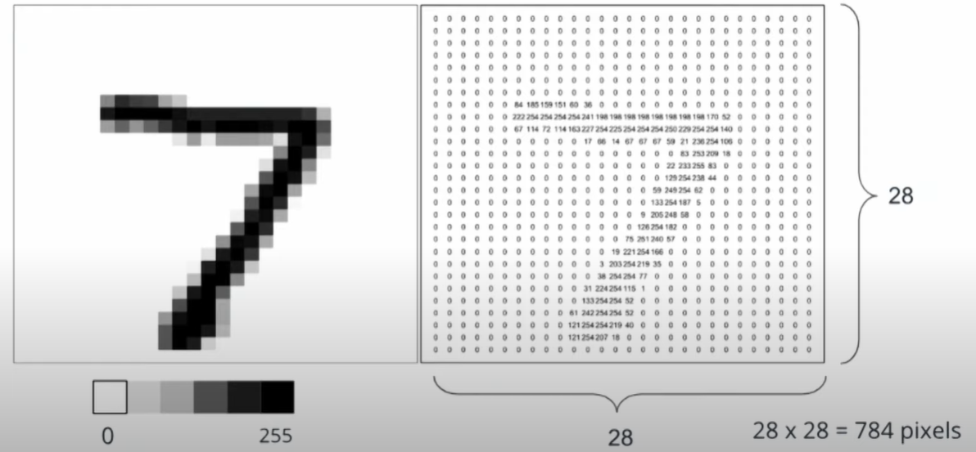

The value given in the image above would have 784 pixels and these are important for what comes next where a deep neural networks are utilized to recognize the image above this is as shown below:

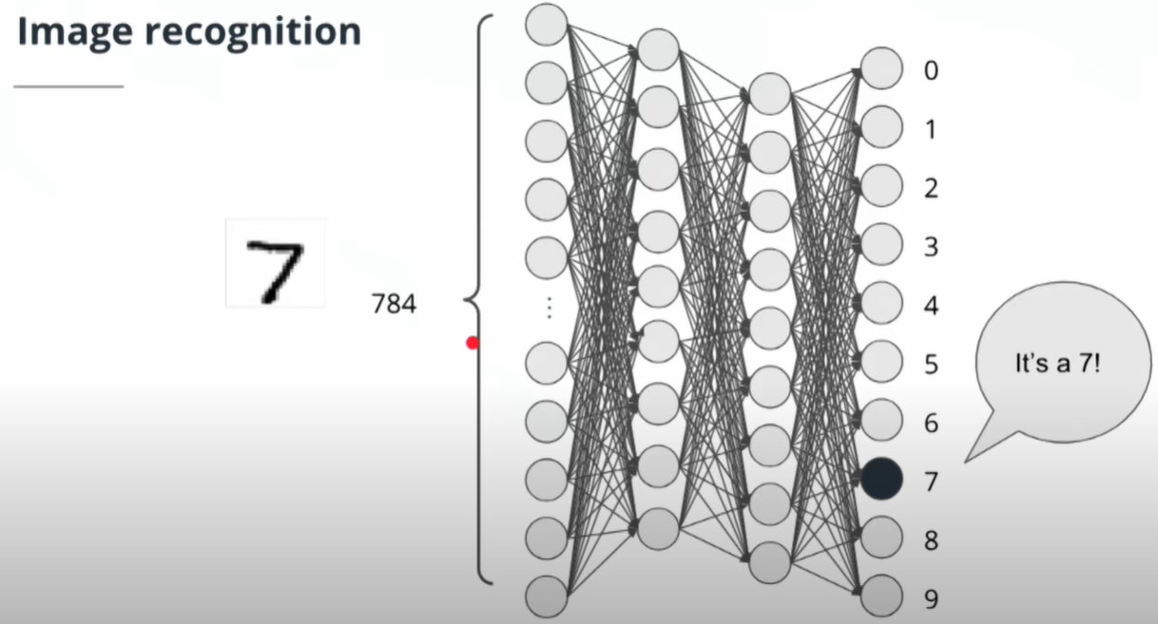

This would then recognize that the image would then be a 7. There neural networks are trained by a large amount of paired input and output values, in this case, handwritten numbers are used. One of the usual cases you can find this is in postal services, where AI is trained by lots of handwritten data and the output is inspected. This can be shown in the image below.

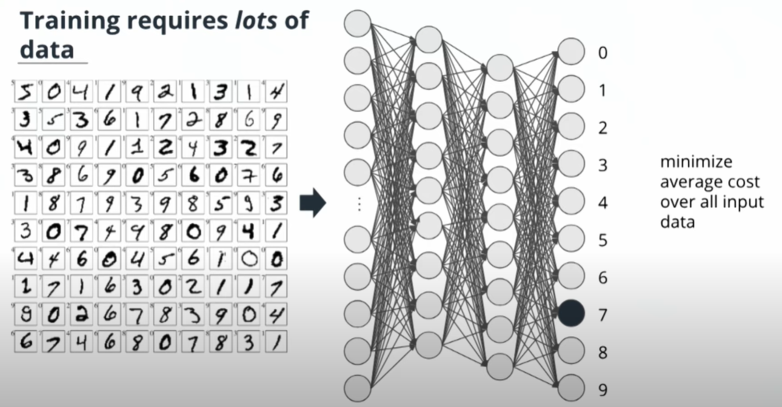

# Current State of AI

In this day and age AI can do the following tasks rather well:

* Specific, narrow tasks
* Learning from large volumes of unstructured data

Also known as first generation AI applications, these are referred to as Artificial Narrow Intelligence. These systems are all over the place in our daily lives. Its what Facebook uses to recognize our faces from images to tag users. Siri to recognize your voice and act accordingly. These tasks are usually narrow and discreet. There are certain tasks that AI can perform better than humans and these are usually games but these again are limited to narrow and specific tasks.

Similarly to humans, AI can be really good at:

* Optical character recognition
* Classification of images
* Handwriting recognition
* Facial Recognition

However, there are things AI is rather bad at and that is doing anything that is outside of what it is trained to do. It is known that AI is quite bad at doing more complex tasks for now. These tasks can be listed as follows:

* Captions & visual descriptions of imagery
* Various robotic tasks(Stable bipedal locomotion)
* General speech recognition
* Complex logical reasoning
* Tasks that are difficult without contextual knowledge
  + Translation
  + Explainability

What can AI do?

“We are at the brink of being able to take an AI, [have it] look over our shoulders, and then [it will] make us maybe 10 or 50 times as effective at these repetitive things” – Sebastian Thrun

# Outro

AI is an umbrella term that describes many different computer science techniques. All of them require data in order to learn information. AI has applications in every industry and is already being deployed to bring down costs and drive efficiency all over the place. The current state of AI is very narrow in its application and has a long way to go before we get into science fiction movies.

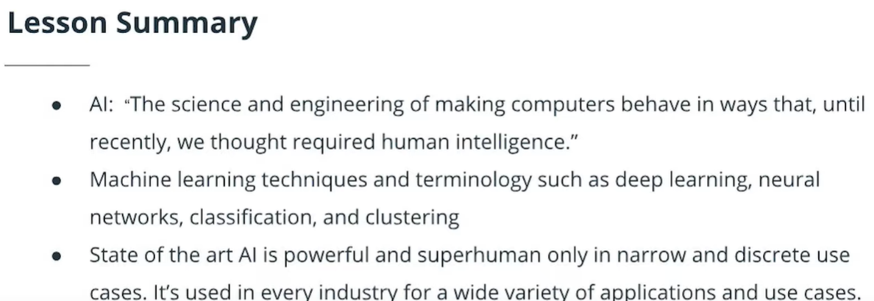

Currently, which of the statements are true:

1. AI can recognise handwriting really well.
2. AI can recognize words spoken in accents.
3. AI can visually describe an image
4. AI can perform multiple robotic tasks at once.

Answer: A

References:

https://www.investopedia.com/terms/n/neuralnetwork.asp